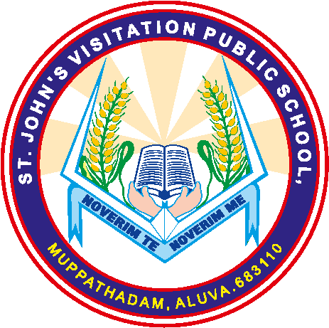 ST. JOHN’S VISITATION PUBLIC SCHOOL
MUPPATHADAM, ALUVA, 683110
Affiliated To CBSE , Affiliation No: 931198
Ph: 0484 2607255, 9061364002
Email: visitationsch@gmail.com
www.stjohnsvisitationschool
STAFF (TEACHING)
SL. NO | INFORMATION | DETAILS
1 | PRINCIPAL | SR. ROSAMMA A. A
2 | TOTAL NO. OF TEACHERS | 30
 | PGT | 0
 | TGT | 11
 | PRT | 19
3 | TEACHERS SECTION RATIO | 3 : 1.9
4 | DETAILS OF SPECIAL EDUCATOR | SPECIAL EDUCATOR - 1
5 | DETAILS OF COUNSILLOR AND WELLNESS TEACHER | COUNSILLOR – 1  WELLNESS TEACHER - 1

