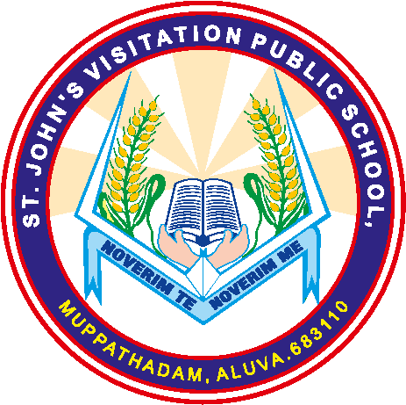 ST. JOHN’S VISITATION PUBLIC SCHOOL
MUPPATHADAM, ALUVA, 683110
Affiliated To CBSE , Affiliation No: 931198
Ph: 0484 2607255, 9061364002
Email: visitationsch@gmail.com
www.stjohnsvisitationschool

RESULT CLASS : X

SL. NO | YEAR | NO. OF REGISTERED  STUDENTS | NO. OF STUDENTS  PASSED | PASS PERCENTAGE | REMARKS
1 | 2017 - 2018 | 17 | 17 | 100 %
2 | 2018 - 2019 | 21 | 21 | 100 %
3 | 2019 - 2020 | 21 | 21 | 100 %

