SL. NO | INFORMATION | DETAILS
1 | NAME OF THE SCHOOL | ST. JOHN’S VISITATION PUBLIC SCHOOL, MUPPATHADAM.
2 | AFFILIATION NUMBER | 931198
3 | SCHOOL CODE | 76175
4 | COMPLETE ADDRESS WITH PINCODE | ST. JOHN’S VISITATION PUBLIC SCHOOL, MUPPATHADAM (P.O), ERNAKULAM (Dt.), ALUVA, KERALA - 683110
5 | PRINCIPAL NAME AND QUALIFICATION | SR. ROSAMMA A.A , M.A , B.Ed
6 | SCHOOL EMAIL ID | visitationsch@gmail.com
7 | CONTACT DETAILS | 0484- 2607255

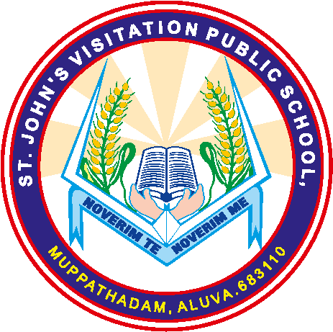
ST. JOHN’S VISITATION PUBLIC SCHOOL
MUPPATHADAM, ALUVA, 683110
Affiliated To CBSE , Affiliation No: 931198
Ph: 0484 2607255, 9061364002
Email: visitationsch@gmail.com
www.stjohnsvisitationschool

